Xceleration Media Launches New Video Series

Xceleration Media Group®, a leading automotive aftermarket multi-channel marketing company, announced the launch of a new video web series that will be shown on its YouTube channel. The Life will highlight the talents found within car enthusiasts across all forms of the automotive lifestyle. Episode 1 of The Life titled Self-Made Man is scheduled to air Friday, February 17, on the Xceleration Media YouTube channel (https://www.youtube.com/XcelerationMedia).

Self-Made Man features Lonnie Johnson of CPC Customs, who has found his niche building one-off customs and hot rods while overcoming the challenges of owning a fabrication shop in a small rural Mississippi town. If Johnson can’t find a replacement part, he uses the minimal tools at his disposal and the teachings of his mentors to make it, in the process creating rolling works of art.

Produced by XM Video Production Manager Zach Tibbett, Self-Made Man was shot on location by XM videographers Derric Curran and Alistair Clark during a two-day period in January.

“I actually met Lonnie some years ago, and although I knew he worked on cars, it wasn’t until recently that I learned of his talent for building high quality customs the old fashioned way,” XM Operations Director Shawn Brereton says. “As I learned more about him, I saw an opportunity for this new series to showcase people’s talents across the automotive hobby. Now that we’ve got the pilot completed, I can’t wait to see what else our talented video crew creates!”

For his part, Johnson was humbled. “I had been telling Shawn for a while now that he needed to come down to see some of the projects I’ve been working on. Little did I know he was going to send a video crew! For a small shop like mine, it is humbling to be recognized and just validates the hard work I’ve put in all these years. The XM video crew were a lot of fun to work with.”

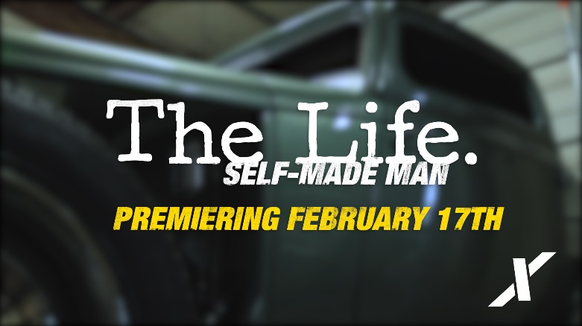
Tibbett, Curran and Clark were excited to shoot the project.

“We’ve been so busy getting the video studio up and running, then editing all of the product videos we shot at SEMA and PRI that we haven’t had much of an opportunity to work on truly creative projects,” Tibbett says. “When we went to CPC to scout the shoot, we just loved the grittiness of the setting and Lonnie’s confidence in what he is able to do. We knew this was the perfect starting point for The Life. We’ve already got our wheels turning on the next one!”

Xceleration Media’s filming talents have been recognized in the past with one of their Gearhead Stories shot by Derric Curran being selected as a Top 9 Finalists in the Optima Batteries Ultimate FilmFest during the 2015 SEMA show.

For more information on sponsorship opportunities for The Life, inquiries can be directed to Ivan Korda (ikorda@xcelerationmedia.com), 901.260.5910.

About Xceleration Media Group®
Xceleration Media Group® is an automotive focused, multi-channel relationship marketing company at the forefront of today’s changing media landscape. With properties in five major automotive/motorsports segments, Xceleration Media uses a variety of innovative delivery channels to ensure its hard-hitting technical content reaches high-value enthusiasts, racers, and hobbyists. Also visit us online at xcelerationmedia.com or on YouTube at youtube.com/xcelerationmedia.

Media Contact: sales@xcelerationmedia.com, 901-260-5910

